Java 8

Lambda expression:

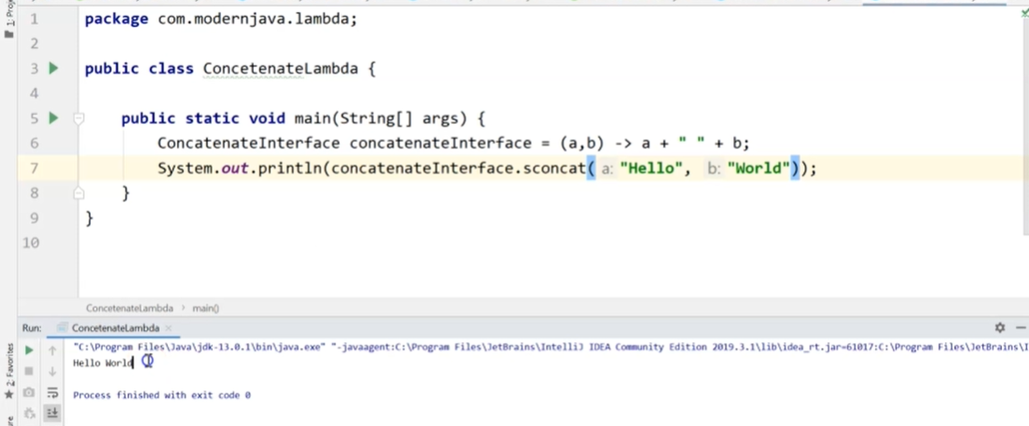

Stream API:



